

Best Practices

Concierge Maintenance

Managing Messages

Throughout The Concierge Assistant, the Messaging feature plays a valuable role in communicating information. Everything from a Contact’s status to the final disposition of a Lost and Found article can be relayed to any employee on property who is authorized to use The Concierge Assistant.

With all of these wonderful messaging features and opportunities, it is important that maintenance be performed periodically to keep the system clean and running efficiently.

There are four (4) areas that require maintenance.

Personal Message Center Day Book (a.k.a. “the little green book”)
Most of the messages received can be saved to an individual “Personal Message Center Day Book”, enabling use at a later time without the need to resend the message over and over.

The Personal Message Center Day Book can hold a lot of messages but can ultimately become filled to capacity. If enough people are not cleaning out their Personal Message Center Day Books, response time can be slowed down and eventually become jammed. It is therefore a necessary and very simple procedure to clean out the old messages that have been saved but are no longer needed.

To clean up your Personal Message Center Day Book click on the tab labeled “Others”.

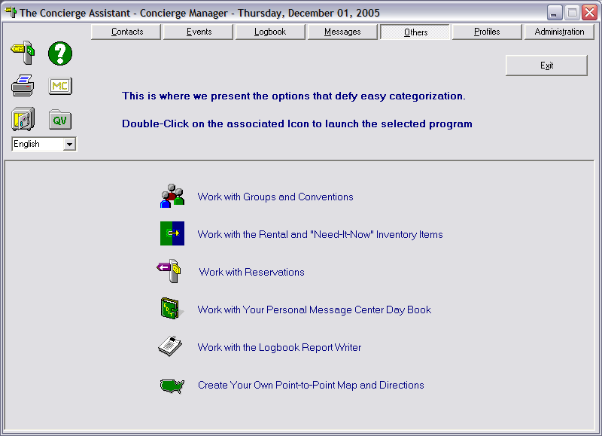

Double click on the icon “Work with Your Personal Message Center Day Book”.

The following screen will appear displaying the messages that are currently stored in your Personal Message Center Day Book.

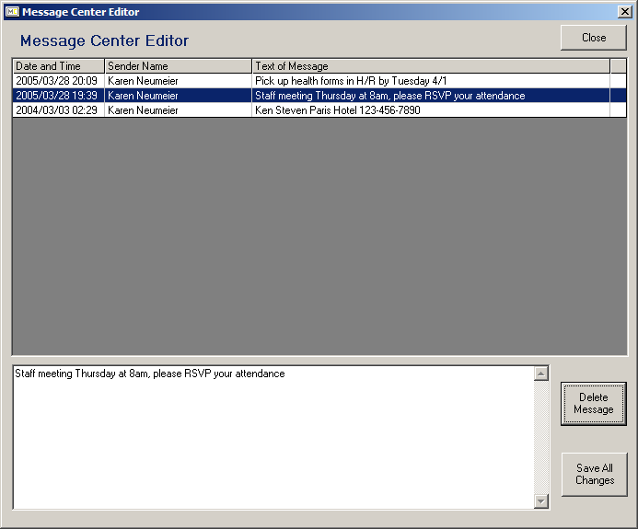

Highlight the message that you no longer need or want by double clicking on it. It will appear in the display area. Now click on the “Delete Message” button. Continue with this procedure until all of the unwanted messages have been deleted. When you are done, click on the “Save All Changes” button. This will return you to the “Others” screen.

Message Center (MC)

As part of CA’s Messaging system, authorized individuals may tell The Concierge Assistant to post a message to the Message Center, indicated by the MC icon on the main screen display, by placing a checkmark in the box labeled “Send to Concierge Message Center”.

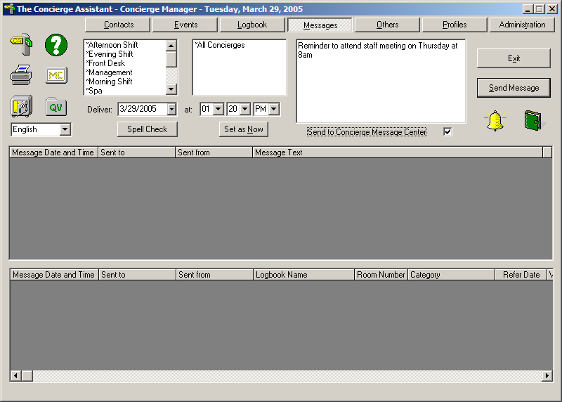

When the “Send Message” button is clicked, the message will be posted to the Message Center in addition to being sent to the recipients indicted in the large white center area. Messages will remain posted here until they are cleared away.

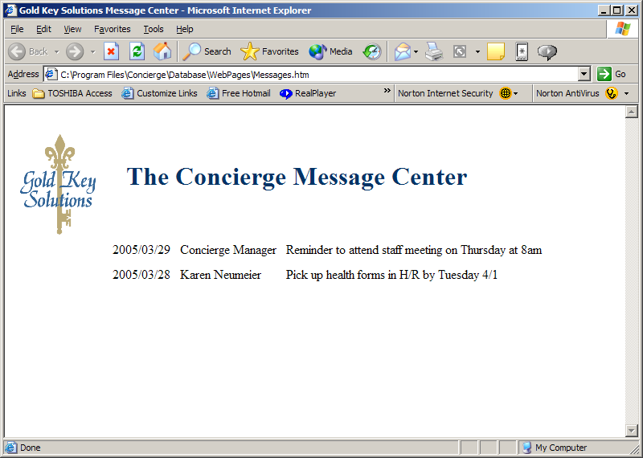

To clean up any old and unneeded messages, you must be an “Authorized” user. This means that you must have the rights to the Administration feature in The Concierge Assistant.

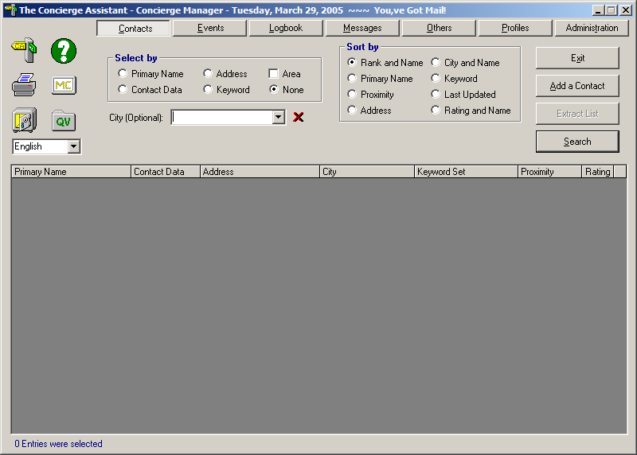

Click on “Administration”; go to the “Configurations Options” button and then to the “Other Options” tab. At the bottom of the screen, you will see “The Concierge Message Center” in bold print. Click on the “Edit” button.

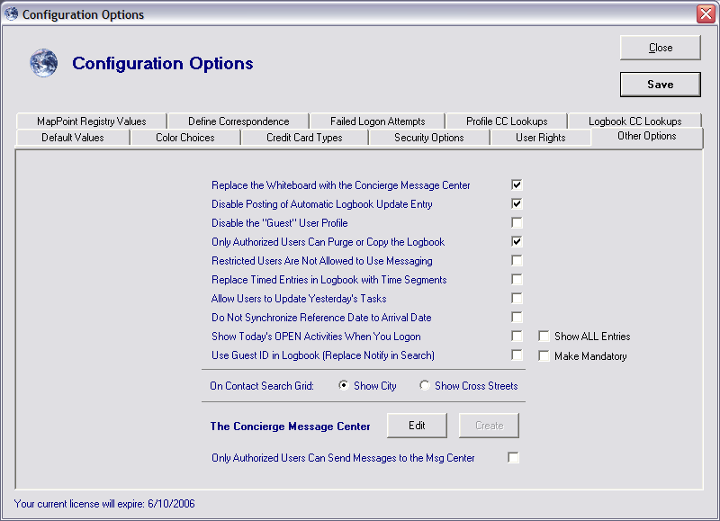

The Concierge Assistant will present the Concierge Message Center screen, as below.

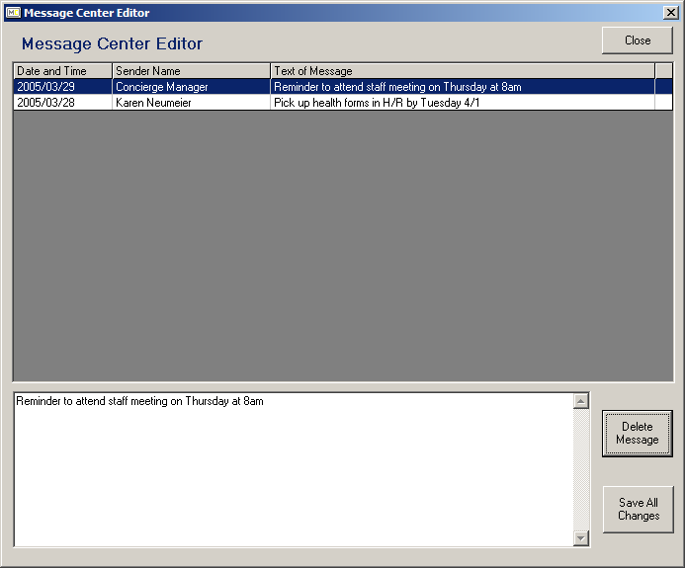

Highlight the message that you no longer need or want by double clicking on it. It will appear in the display area. Now click on the “Delete Message” button. Continue with this procedure until all of the unwanted messages have been deleted. When you are done, click on the “Save All Changes” button. This will return you to the “Configurations Options” – “Other Options” screen.

Managing Messages (under Administration).

The third area that requires cleaning up also requires that you be “Authorized”. Under the “Administration” tab is a button labeled “Manage Messages” and the screen looks like this.

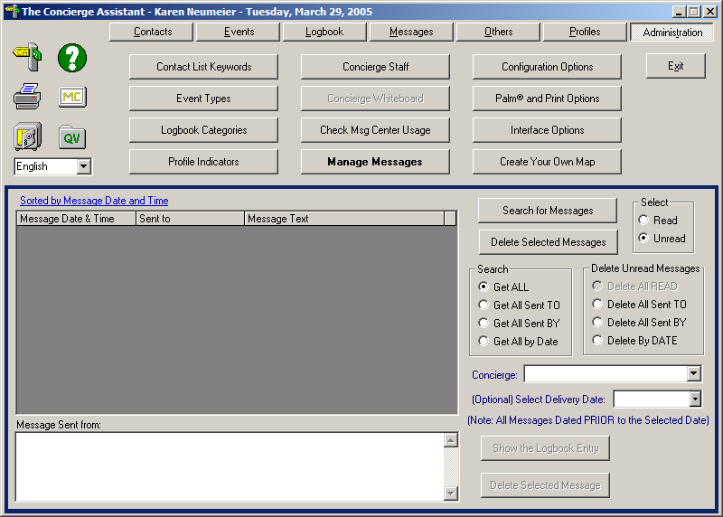

With this screen a variety of selections is available to you. You may look at all available messages, read or unread, to every person Sent To or Sent By or by the Date Sent, within the property, using The Concierge Assistant. Once your selections have been made, click on the “Search for Messages” button.

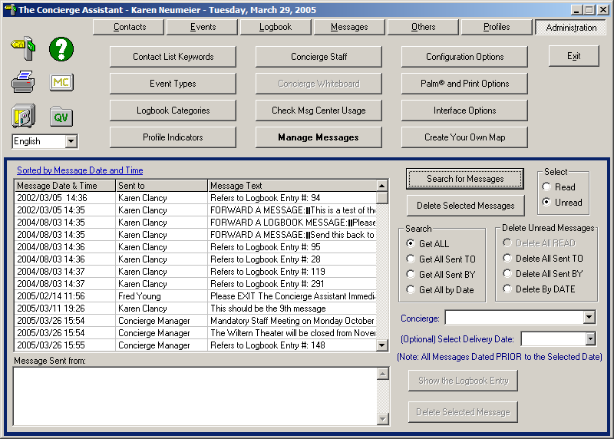

The Concierge Assistant will display every message that falls within those parameters. These messages can be sorted by “Message Date and Time” as well as by “Concierge Sent To”.

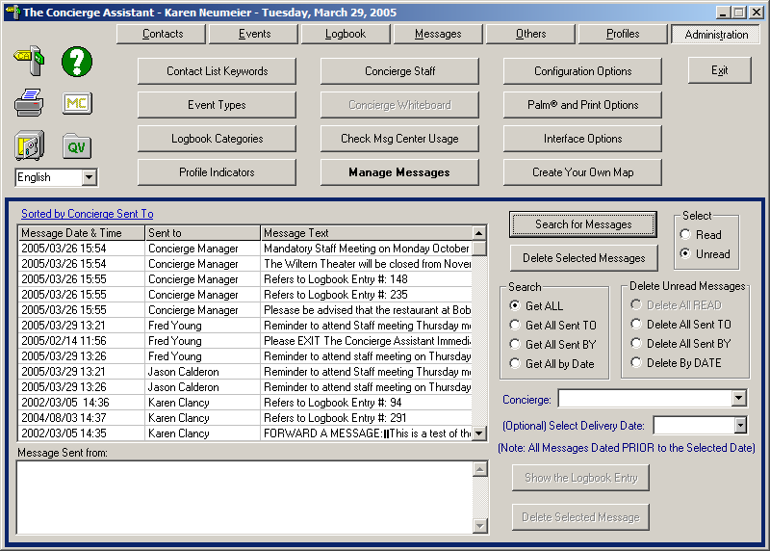

Messages can be deleted one at a time or in groups such as the concierge Sent To or Sent By, or the Date Sent. When you have made your selections, click on the “Search for Messages” button.

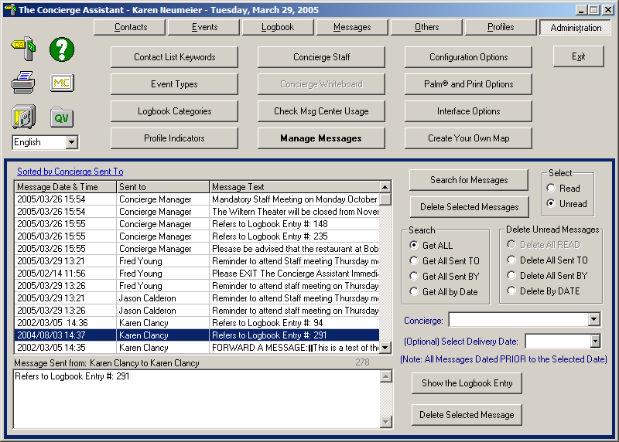
To delete individually, double click on the message to be deleted and click on the “Delete Selected Messages” button.

If the message was from a logbook entry you will also have the option of looking at the Logbook entry the message refers to.

To delete by groupings such as, Sent By or Sent To or By Date, all that is necessary once the selections have been made and searched is to click on the button labeled “Delete Selected Messages”. (NOTE: All “Read” messages are deleted automatically when the Logbook Archive maintenance is performed.)

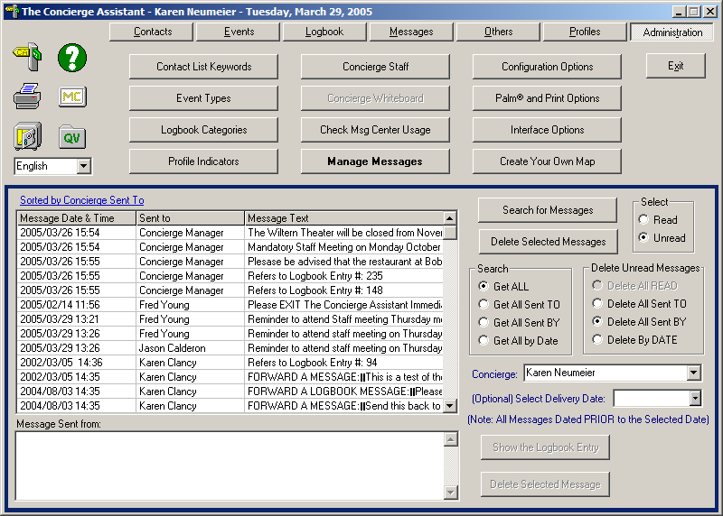

Managing Concierge Staff (under Administration).

The fourth and final area that requires maintenance up also requires that you be “Authorized”. Under the “Administration” tab is a button labeled “Concierge Staff” and the screen looks like this.

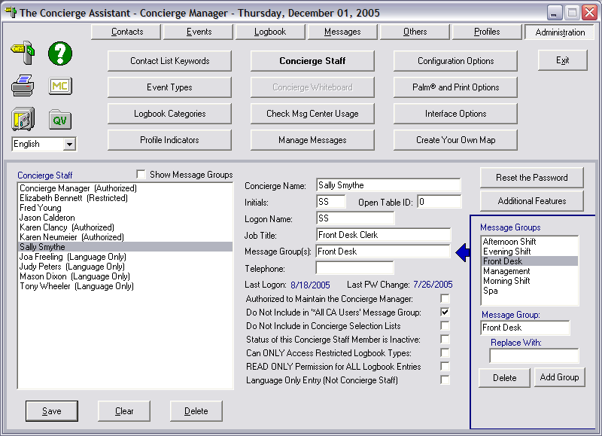

To eliminate unnecessary messages being sent to users who normally would not be included the message distribution be sure to check the box – Do Not Include in “*All CA Users” Message Group.

These few steps done regularly will help keep the Concierge Assistant clean and operating efficiently.

